21
LIFESTYLE//HOUSTON BELIEF

From one book to a million: The story of a Houston nonprofit's literacy mission

Lindsay Peyton, Correspondent
Dec. 28, 2021Updated: Dec. 31, 2021 9:43 a.m.
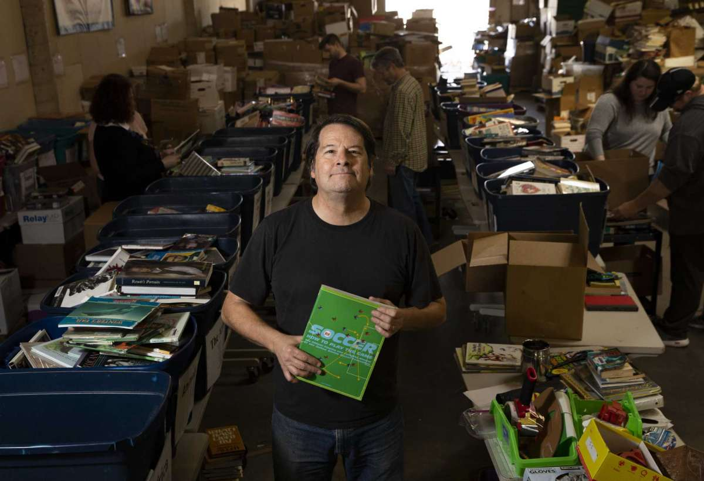1of21
Mark Cotham, the founder and president of Books for Development, poses for a portrait Thursday, Dec. 23, 2021, at East Downtown in Houston. Books for Development is a nonprofit organization birthed out of a church that seeks to end the book famine in the developing world.
Yi-Chin Lee, Houston Chronicle / Staff photographer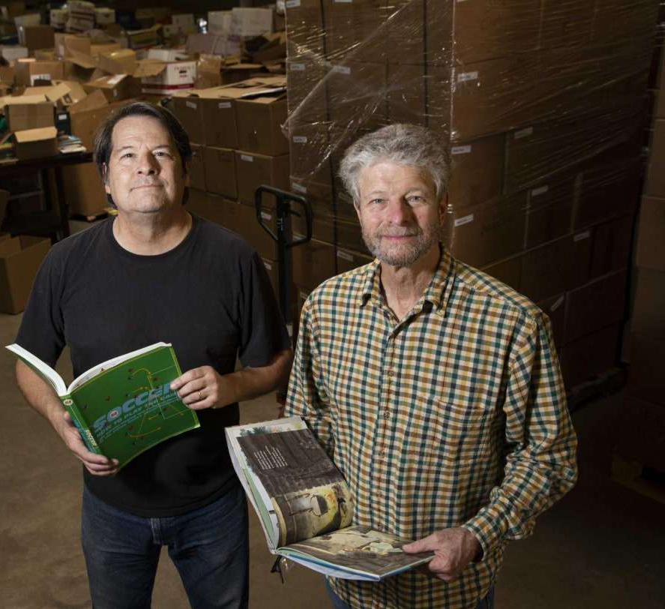

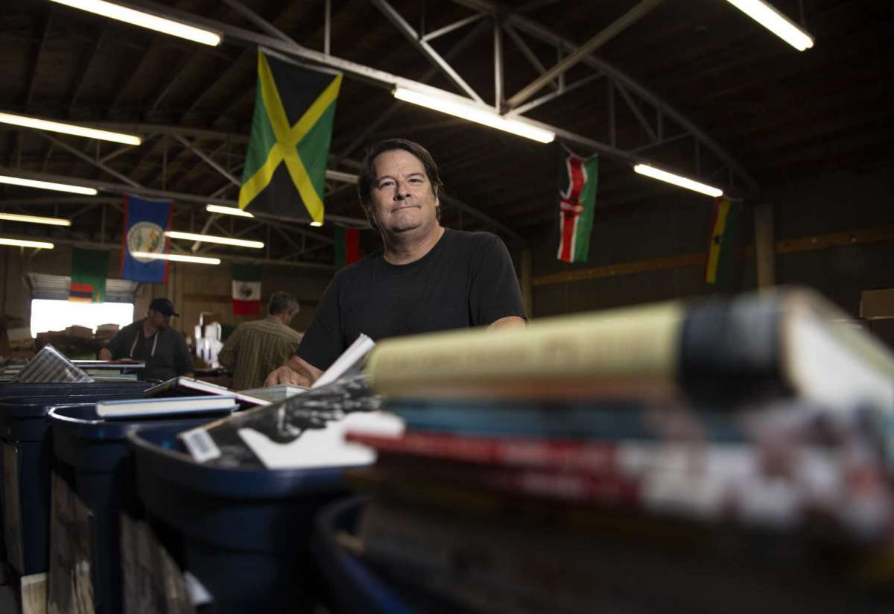

Picture a shipping container — 40 feet long, 8 feet tall and 8 feet wide — filled to the brim with books. Twenty pallets of them.
With 2,000 books per pallet, each cargo container can carry a total of 40,000 titles. Mark Cotham has done the math. He is the founder and president of Books for Development, a Houston-based nonprofit on a mission to make literacy a reality for all in the developing world.
Recently, the organization sent its millionth book, which means more than 25 cargo containers have been filled in the past decade. During that time, the nonprofit has also established 400 libraries around the world.
It all started as a church project. For nearly four decades, Cotham has been a member at Chapelwood United Methodist, located in Piney Point Village. In 2010, during the congregation’s annual Faith Alive program, which addresses the needs of the underprivileged, it was his turn to brainstorm what the congregation would do.
Cotham knew exactly where he wanted to focus. “I had been to Africa three or four times before,” he said. “I wanted to figure out how to do that on a permanent basis. I fell in love with the people. I just enjoyed being over there so much.”
He tried various ventures in the past to help residents of Uganda, including introducing solar ovens and assisting orphans, especially those who lost their parents to AIDS.
But after asking a number of villages about their major needs, a clear answer emerged: “It was unanimous — 20 out of 20 villages said the greatest need was education for their children,” Cotham recalled.
In the rural places he visited, parents were busy working for about 84 cents a day, and there were few books, if any, for the children. Even textbooks at school were shared by several students.
So, when Chapelwood United Methodist Church needed a project, Cotham suggested a mega book drive — a whole shipping container full of hardcovers.
Everyone at the church got involved — from the youth choir to senior groups. Each sponsored a school where the books would eventually land.
“We started asking people for books at Chapelwood,” Cotham said. “And it was amazing. So many people had a surplus of books and didn’t know what to do with them.”
There were many in the community culling their personal collections or getting rid of children’s books now that their kids were grown. As e-readers grew in popularity, libraries weeded out their books as well. Before long, the church's boxes of books were full.
But that wasn’t the end of the drive.
“Members volunteered, and we took two groups from Chapelwood to Uganda, back-to-back,” Cotham recalled.
In 2011, church members worked side by side with schools to transform a room into a library. The experience was more than rewarding, Cotham explained.
“To put books in the hands of kids in Africa was the single most addicting thing I’ve ever done,” Cotham said. “Almost none of these kids were able to walk up to a stack of books before.”
Peggy Burck was also on the trip. While not a member of Chapelwood, a friend in the congregation suggested she help collect donations.
“The rest is history,” said Burck, who would later become CEO of the organization. “I fell in love with the project.”
She went from sorting books to building libraries across the ocean. “Mark really did this on faith,” she said. “And we didn’t go to big cities. He took us where no one else wanted to go. We were in very remote corners of Uganda.”
“It’s such a simple, basic way to provide something really in need,” she said. “And we have such an abundance of books in Houston.”
Books for Development was incorporated into a separate 501c3, apart from Chapelwood, in 2012. Cotham explained that the outreach effort needed to expand beyond the walls of one church.
“That kind of service is at the core of Methodism,” Cotham said. “And there were a bunch of other churches and denominations we could work with.”
These days, many faiths assemble to sort donations for Books for Development.
“Whether it’s Judaism, Islam or Christianity, we have a central tenant to help our fellow man,” Cotham said.
Youth groups, high schoolers and book lovers of all ages volunteer. They assemble from 9 a.m. to noon on Saturdays, sorting and boxing titles.
In 2018, the nonprofit leased its own warehouse, located at 3709 Polk. Before, the Houston Food Bank offered storage space in its warehouse.
Currently, books are sent to Uganda, Kenya, Zambia, Malawi, Botswana, Ghana and the Democratic Republic of Congo, Peru, Belize, Jamaica, Mexico, the Harris County Jail and Native American reservations in the U.S.
Books for Development has helped establish libraries in schools, prisons and even the national zoo of Uganda. In addition, mobile libraries have been created for refugee camps.
“We try to get every book where it needs to go,” Cotham said. “Each book will be treasured. We find really good homes.”
The nonprofit is also starting a new program to train librarians.
“The concept is we’re developing people, resources and communities by building libraries,” Cotham said.
He compares the all-volunteer organization to the “Stone Soup” folktale, where everyone shares something small to make a large meal all can enjoy.
“It’s just a ‘Stone Soup’ adventure,” he said. “Everyone brings something different.”
Burck explained that before sending each book, volunteers ensure they are in good shape and appropriate for the particular audience. Then, the titles are sorted by subject.
“It’s basically a pop-up library — out of the box, onto the shelves and voilà,” she said.
Rounding up titles has become the easiest part of the project, Burck added. Volunteers are essential to sort and package, as are donations to cover the cost of shipping.
“That’s our biggest expense,” Burck said. “Shipping is the only thing that slows us down.”
The cost is well worth it, she added.
“I’ve seen people receive the books, children who have never held a book before,” she said. “It never gets old, the wonder in their faces.”
The teachers are also appreciative of the new libraries, Burck said. Their students typically score higher on standardized tests after the books are added.
“There’s no question that there’s a benefit,” she said.
While other groups send books around the world, Burck said it’s the follow-up that sets Books for Development apart.
“It’s not just one and done,” she said. “We establish a bond with each community we go to.”
How to help
How to help
Donations can be made online at booksfordevelopment.com. Individuals and organizations can sign up to volunteer at volunteerhou.org.
The organization has continued its work throughout COVID. While travel prevented volunteers from building libraries, Cotham, Burck and board members were still able to go.
“When you think it can’t possibly happen, it does — and that encourages us,” Burck said.
It affirms her faith, she added.
There are many moments that have felt the same way for Cotham. Even the fact that the first book drive was successful was a godsend, he said.
To watch it grow and blossom has felt even more inspiring.
He was concerned about finding enough material about animals when Books for Development was contacted to establish a library at the Uganda Wildlife Education Center. But that same morning, Cotham picked up a donation of 20 boxes — and about 19 were about animals. “Sometimes the Lord is not so subtle,” he said with a smile.
“I have a simple belief, if you’re a Christian, that you ought to do the things Jesus would do,” Cotham added. “Jesus would care the most for the people with the least. He would do the best he could for them.”
It’s an example that Houstonians can follow. “People are throwing away books in the U.S. that could bring a lot of joy somewhere else,” Cotham said. “It’s an opportunity we shouldn’t let slip away.”
He continues to drive in his pickup to load most of the donations for Books for Development. He never tires of his commitment to build literacy in other countries.
“It’s incredibly easy to call up in my mind’s eye the children who will pick the books up,” he said. “It’s easy for me to see what a difference the books will make to the children. It’s easy to know people really want and need these books.”
Burck agreed. “It’s something that touches anyone who has a giving heart and a loving soul. We have extra and we want to share,” she said. “It’s opening doors. It’s opening minds. And it opens your heart in ways you never even imagined.”
Lindsay Peyton is a Houston-based freelance writer.

